**DATE SUBMITTED:** 10/2/18

**Task 0**

Execute the provided code, no submission is required.

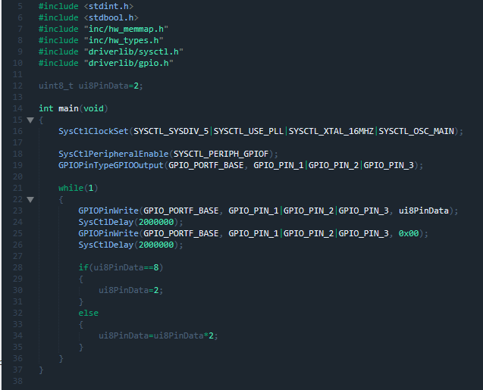

**Youtube Link:** <https://youtu.be/3wZSR9PdksI>

**Task 1**

Determine the current period and on - time of the LED blinking. Change the delay of the LED blink (approx. 0.425 sec) by changing the delay and clock source and configuration – determine the CLK frequency – verify the delay to be approx. 0.425 sec.

Using an equation from a previous lab we can find what the delay needs to be set to in order to obtain a 0.425 sec delay.

(0.425/((1/40(MHz))*3)) = Delay = 5.67 * 10^6

Next we have to find the value of the divisor

(40(MHz)/x) = 5.67 * 10^6 => x = 7.059

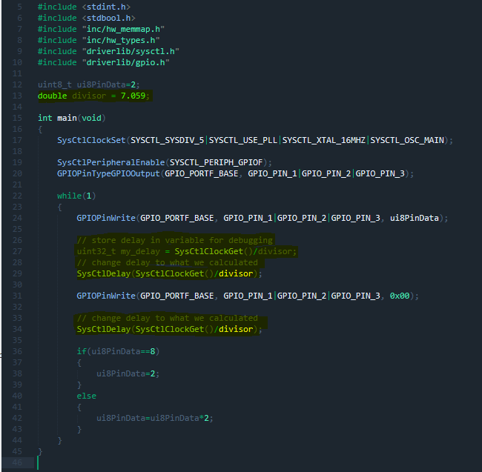

**Youtube Link:** <https://youtu.be/3dohEMnPA90>

**Task 2**

Change the sequence of LED blinking to R, G, B, RG, RB, GB, RGB, R, G, … with the same delay.

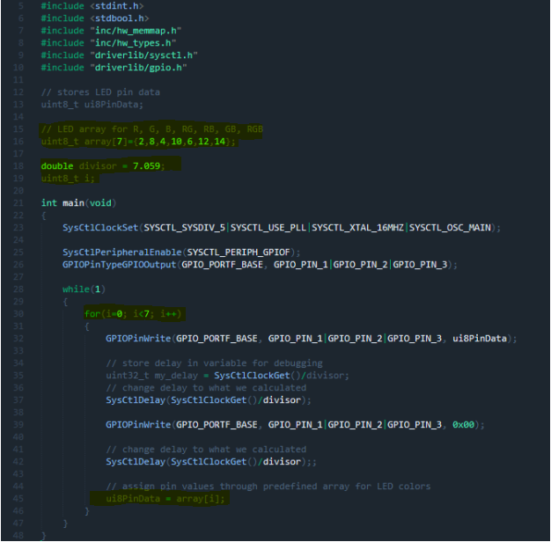

**Youtube Link:** <https://youtu.be/s-eMG0m1yJ0>